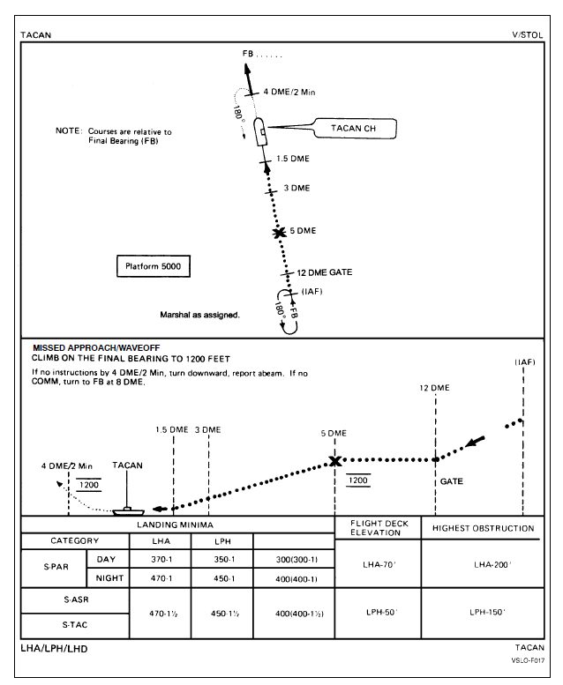

**LHA Straight-In TACAN**